From the High Commissioner’s Desk
24th January 2020
As Australia’s new High Commissioner to Solomon Islands, I’m delighted to continue the tradition of fortnightly conversations with Solomon Star readers through this column. It’s an honour to serve here in Solomon Islands, a neighbour with warm and enduring ties to Australia. I take this opportunity to acknowledge the magnificent contribution of my predecessor, Rod Brazier, and his dedication to strengthening the relationship which binds our two countries together in so many ways.
I was honoured to present my letter of credentials to Prime Minister Manasseh Sogavare the very day after I arrived in Honiara. Australia and Solomon Islands enjoy strong relations built on shared values, common regional interests and enduring community links. I look forward to working with the Prime Minister and his government as we drive our partnership forward.
I was also delighted to meet Governor General Vunagi, who has already given so much to his country as a teacher and a church leader.
Unfortunately Australia has been battling the large-scale bushfires which have been ravaging parts of country for some months. We are well-organised and well-resourced to respond, but the scale and heart-breaking impact of these bushfires have been unprecedented.
My home in Canberra was covered in thick smoke in the weeks before I departed for Honiara. Fires have now broken out on the outskirts of the city. They are being put out, but they are another reminder of the need for eternal vigilance. Bushfires have devastated parts of the South Coast of New South Wales, a region many of us from Canberra know well. Back home, everybody knows somebody who has been directly impacted. Staff members from our High Commission in Honiara have family who have lost homes.

Our thoughts are also with the family and friends of the 29 people who have lost their lives in bushfires this season, including six firefighters who so bravely served their communities.
I have been deeply touched by the compassion of almost every Solomon Islander I have met since my arrival about the terrible toll being exacted by these fires. We are deeply grateful for the number of fundraising events supporting bushfire victims that have occurred across Solomon Islands. I would like to give my heartfelt thank you to Prime Minister Sogavare and his Government’s for its generous donation last week, and to all local communities who have make donations towards the cause.

Solomon Islanders have shared their thoughts and prayers with those affected by the bushfires, reinforcing again that we truly are there for each other through thick and thin.

This is my first posting to Solomon Islands, after a long and rewarding career in Australia’s foreign service. I joined the Australian Department of Foreign Affairs and Trade in 1993, serving overseas in Bonn in Germany, Seoul in South Korea, New Delhi in India and Geneva in Switzerland. I ran our Pacific Regional team in 2013, serving as Australia Pacific Islands Forum senior official and visiting Solomon Islands twice. I later ran the international branch in the Department of the Prime Minister and Cabinet which covers the Pacific for two years.

The Pacific has always been dear to my heart. I am a historian my training, completing a PhD on Australia’s relations with China at Monash University. I have written two books. The second, Day of Reckoning, which traced Australia’s efforts to re-establish law and order in Papua New Guinea after the Second World War, was short-listed for the New South Wales Premier’s Australian history prize in 2006.
My wife, Lily, will be joining me in a couple of weeks. Reflecting Australia’s wonderful cultural and ethnic diversity, she was born in Macedonia and came to Australia when she was one. We were married in the Macedonian Orthodox Church in 1991. Lily is completing her PhD at the University of Canberra, examining identity in contemporary Australia.

For the first time Lily and I will not be accompanied on a diplomatic assignment by our children. Our son, Joschka, will start work as a registered nurse at Canberra Hospital in February and our daughter, Katya, will commence a science degree at the Australian National University in Canberra in several weeks. We will miss them sorely but they have promised to come to Honiara often. They had better.

On a lighter note, everyone should know that I have sadly not inherited my dear father’s wonderful singing voice, but I have taken on passionately his allegiance to the Australian rules football team, Carlton, otherwise known as the mighty Blues. I will try to persuade as many locals as possible to support the great Carlton cause. They should feel free to ignore the false blandishments of any other Aussie rules teams.

I have had an incredibly warm and friendly welcome from Solomon Islanders since I arrived, and I am very much looking forward to travelling around this magnificent country, from shore to shore, and meeting with as many people as possible, as soon as possible. I look forward to learning about Solomon Islands’ incredible cultural and environmental diversity as I travel across the country. We have so much to do together. Our partnership is deep and strong.

Ends

Photos
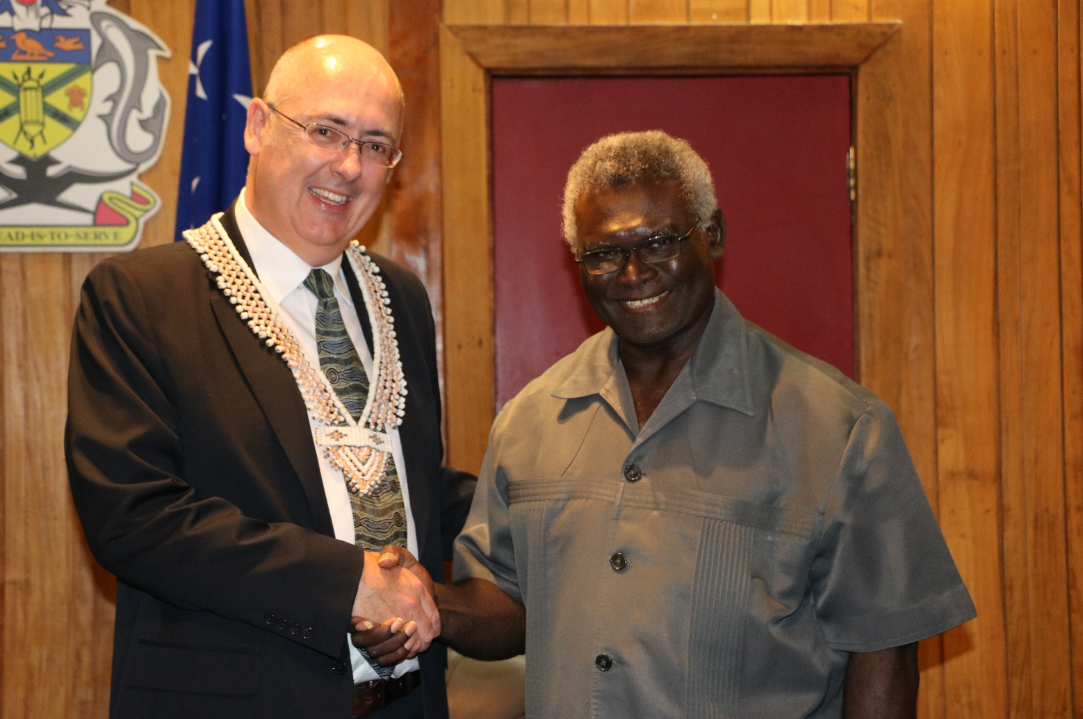
Photo 1: High Commissioner Dr Lachlan Strahan shakes hands with Prime Minister Manasseh Sogavare after presenting his letter of credentials at the Prime Minister’s Office.
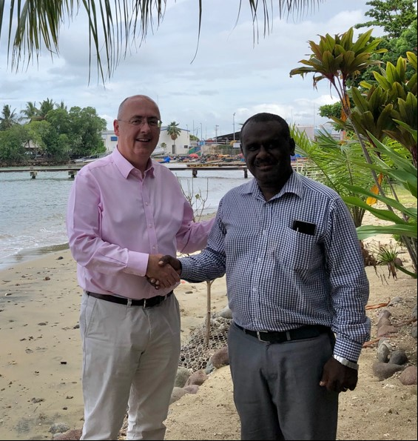
Photo 2: High Commissioner Strahan shaking hands with Minister for Foreign Affairs and External Trade Jeremiah Manele
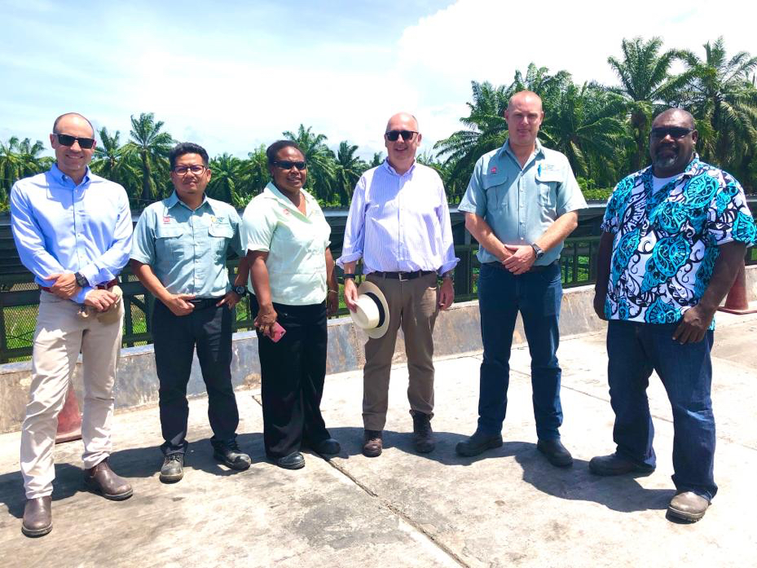
Photo 3: Australian High Commissioner Dr Strahan with the GPPOL General Manager Craig Gibson, Premier of Guadalcanal Province Francis Sade and senior staff of GPPOL and the Australian High Commission.

